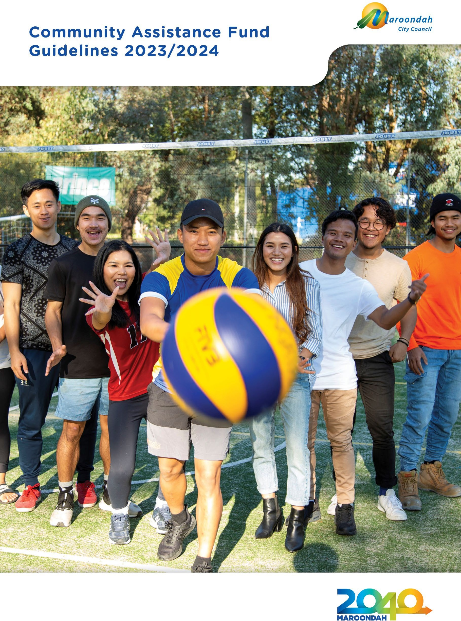

Introduction
Maroondah City Council is committed to building a stronger and better community in Maroondah. One of the ways that Council does this is by increasing opportunities for local residents, and community groups to further reach individual goals and achievements that contribute to community goals.

The Community Assistance Fund has been developed to:
- assist community groups through providing a financial contribution to help meet urgent or unforeseen costs.
- assist individuals to develop and implement initiatives that promote community pride and participation.
- to assist individuals to meet costs associated with participation in community activities such as sporting competitions, arts and cultural activities and self-development initiatives that benefit the community.

The Community Assistance Fund is offered throughout the year however applicants are restricted to one application per financial year per individual or organisation. Applicants are also unable to apply for a Community Assistance Grant if they have already received other Council funding in the same financial year.

Eligibility

Individual applicants
  - Must be a resident of Maroondah.
  - If applicant is under 18 years, parent/guardian is to sign the application form and complete the parent/guardian information section on the application form.
  - The program, service or activity undertaken by the individual must have a demonstrated benefit to the community.
  - Applicants should provide reasonable justification for Council financial assistance to assist in meeting expenses associated with participation in community activities.
  - Evidence of participation is required to support the application (e.g. letter of confirmation from an organisation, association)
  - Applications from five or more participants from the same team or group applying for the same event will be considered as an organisation application.

Organisations
  - Organisations must be an incorporated community group with not for profit status or auspiced by an eligible organisation.
  - Organisations must operate within or provide substantial benefit to the Maroondah community.
  - Maintain Public Liability Insurance Cover ($20 million minimum cover)
  - The request is unable to be considered under Council’s Community Grants Funding Program because it does not meet the application timelines and/or is of an urgent and unforeseen nature.

Ineligible requests
  - Initiatives that do not focus on or benefit the Maroondah community
  - Initiatives that are only in the self interest of the applicant
  - Capital works or minor facility maintenance
  - Applications received after the project or event has occurred
  - Applications from organisations will not be assessed if previous grants have not been acquitted and evaluation form not returned by the due date.
  - Applications from individuals will not be assessed if a previous Community Assistance Fund grant evidence of participation was not returned by the due date.

Assessment criteria
Successful applicants will be required to nominate and meet at least one of the following criteria:

Community building
- Increase participation
- Encourage volunteering
- Provide leadership opportunities
- Increase learning and skill development
- Build a stronger and better community in the City of Maroondah

Community and cultural benefit
- New initiatives that will address a clearly identified community or cultural need.
- Contribution to arts and cultural development in Maroondah.
- Expansion of an existing service to improve service outcomes and community wellbeing.

Conditions of funding
- Programs will not be funded retrospectively (ie. event cannot have already occurred or purchases already made).
- Applicants can only apply once per financial year for Community Assistance Funding and there is no guarantee of funding for future applications.
- Funding is a contribution (25%) towards the total cost of the project or pursuit and is up to a maximum of $1,000 for organisations and $350 for individuals.
- If applicant is under 18 years, parent/guardian is to sign the application form and complete the parent/guardian information section on the application form.
- All sections of the application must be fully completed and include all requested attachments.
- It is a condition of funding that organisations be incorporated under the Associations Incorporation Act or be auspiced by an incorporated not for profit organisation.
- Community Assistance funding payments to organisations will be subject to the Goods & Services Tax (GST) if applicable to your organisation.
- Council reserves the right to seek reimbursement of grant funding from a funded organisation or individual if the required evaluation or acquittal is not provided in a timely manner, or if Council is not satisfied that funds were used for the intended purpose as outlined in the original application.
- Council reserves the right to refuse funding.

Acquittal/evidence of participation

Individual applicants
  - Within one month of attending the event, successful individual applicants are to provide evidence of participation at the event for example; a letter (on letterhead) from an organisation, a newsletter or web based article, or photo at the event.

Organisation applicants
  - Within one month of completion of the project, successful organisation applicants must provide a brief financial acquittal of funds including receipts relating to the grant and complete an evaluation form.

Organisations’ insurance and industry obligations
Community organisations must demonstrate that all relevant insurances are in place and that Public Liability Insurance is held to a minimum cover of $20 million.
Failure to provide this information will result in the rejection of the application. A copy of the certificate of currency covering the 2023/2024 funding period must be included as an attachment. If successful, the applicant should ensure that Council is named as an interested party on the public liability policy.

Acknowledgement of Council
- Wherever possible, acknowledgment of Council funding should be given in any public relations opportunities undertaken by the funded applicant, relating to the request.
- Copies of any examples must be included in the funding evaluation report.
- A copy of Council's corporate logo can be provided for promotional purposes, however, grant recipients wishing to use Council's logo must first discuss their requirements with Council’s Communications and Engagement team. Use of Council's corporate logo will only be approved under these circumstances.

Timeline
Initial contact | Letter, email or phone request received
Within 7 days | Guidelines & Application form mailed or emailed to applicant
Assessment Process | Applications assessed monthly
Within 7 days of assessment | Applicant notified of outcome by email
Upon receipt of invoice for organisation | Invoice required for successful organisation Funds processed and sent upon receipt of invoice
1 month after event / project / purchase | Organisations: Financial acquittal and evaluation form to be submitted within 1 month of funds being expended.  Individuals: Evidence of Participation to be submitted within 1 month of event
Applicants should allow approximately six weeks from the submission of the application for notification of an outcome.
Please note that timelines may be affected slightly due to unforeseen circumstances.

Step-by-step guide to applying for community assistance funding
- Read through the guidelines.

- Check that you or your organisation is eligible to apply and that your request meets the funding criteria

- Council encourages all applicants to contact Council Officers to discuss your request prior to completing the application process.

- Complete the application form, ensuring that all requested information has been included.

- Keep a copy of the completed application for your records

- Forward completed application and relevant documents, in one of three ways:

Post
Community Assistance Fund Administration Maroondah City Council
PO Box 156
Ringwood 3134

Email
maroondah@maroondah.vic.gov.au
With ‘Community Assistance Fund 2023/2024 in the subject heading

In person
Deliver to any of Council’s service centres:
  - Realm: 179 Maroondah Highway, Ringwood
  - Croydon: Croydon Library, Civic Square, Croydon

Privacy collection notice
Maroondah City Council is committed to protecting your privacy as prescribed by the Privacy & Data Protection Act 2014 and the Health Records Act 2001. The information you provide on this form is being collected by Maroondah City Council for the strict purpose of conducting Council business.

Your information will not be disclosed to any external party without your consent, unless Council is required or authorised to do so by law.

Failure to provide the information requested may make you ineligible to receive the service or be part of an event/function that is the subject of this form.

Any access to the information, amendments that may be required or any privacy enquiries may be directed to Council's Privacy Officer & Health Records Officer on 9298 4211 or email privacy@maroondah.vic.gov.au

Need further assistance?
If you require further information, please contact Maroondah City Council Leisure Services Administration Officer on 9294 5709.

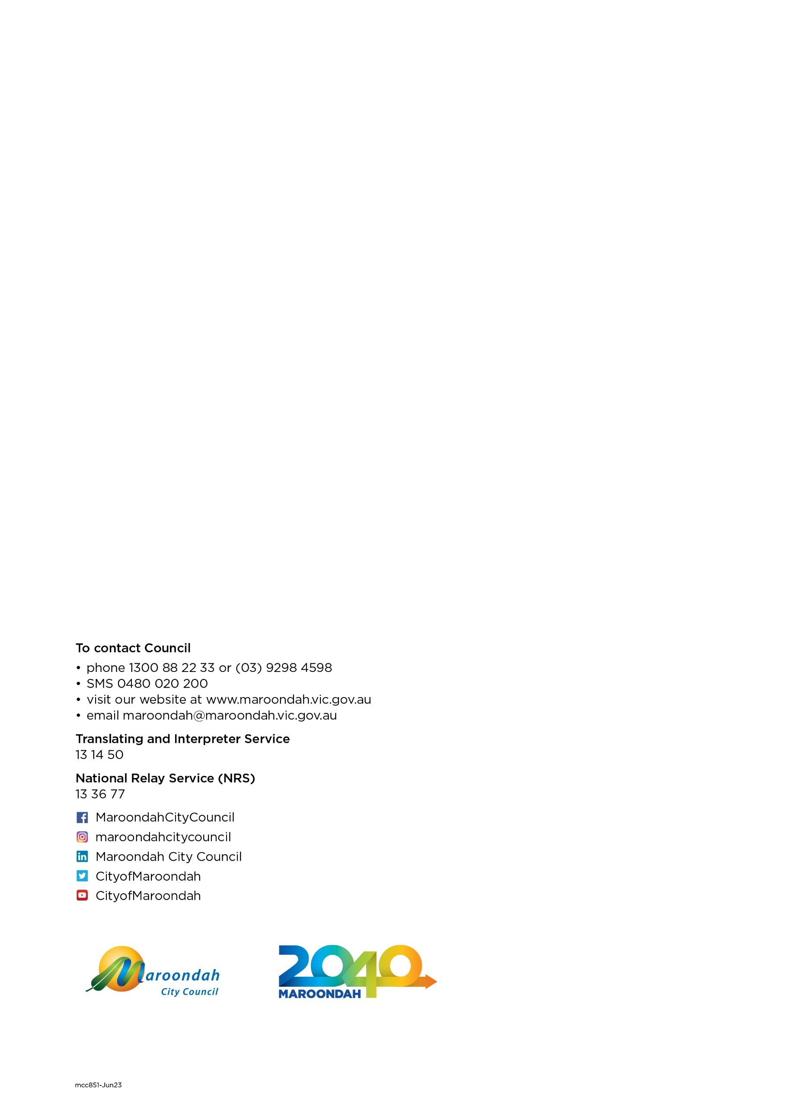

7

