
Temporary Storage Container Permit Information Sheet

This information sheet provides guidance on when a Temporary Storage Container Permit is required and how to apply for one.

Protecting Council’s assets

Please note that it is your (the Applicant) responsibility to ensure that Council’s and other authorities’ assets are not damaged from the placement and removal of the temporary storage container.

When an application for a Temporary Storage Container Permit is received, Council Officers will inspect and record the condition of assets at the property and will inspect these assets again once the container is removed.

A security bond will be held by Council until the temporary storage container is removed and conformation is received that there has been no damage to Council’s and/or other authorities’ assets.

Information required to obtain a Temporary Storage Container Permit

Public Liability Insurance

The owner of the temporary storage container must have current public liability insurance.

The policy must not expire whilst the temporary storage container is in place.

A copy of the Certificate of Currency is to be provided to Council with the application form, which must include the policy number, the expiry date and a minimum coverage amount of $20 million. Also, Maroondah City Council must be nominated as an interested party on the insurance.

A site plan

The plan must show:
- the location of the temporary storage container
- any obstructions (such as signs, trees, Council pits, power poles, water and Telstra pits, street furniture, etc)
- the dimensions of the temporary storage container, the remaining footpath/pedestrian passing area*, and the distance from the kerb, trees, pits etc.

*Please note that a clear footpath width/pedestrian passing area (in areas where a footpath is not provided) of 1 metre wide must be provided at all times for pedestrian use. The temporary storage container must be placed a minimum of 30 centimetres from the back of the kerb to maintain clearance to the traffic lane.

Please make a record of any pre-existing damage to infrastructure and submit this information as part of the site plan.

An example of a site plan is shown in Figure 1 below.

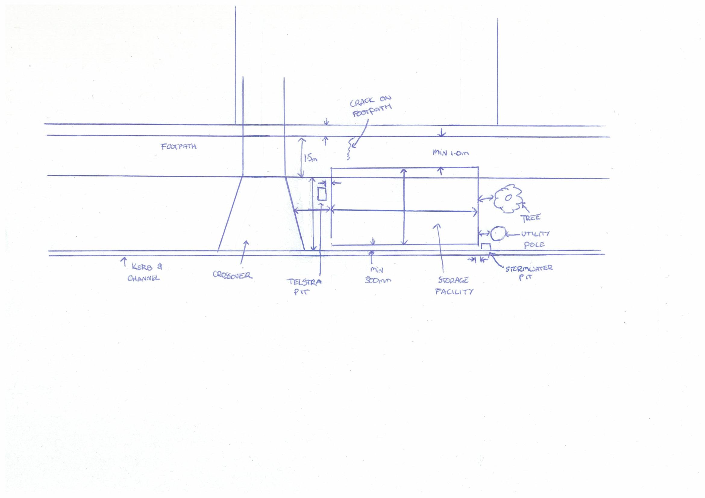
Figure 1: Site Plan Example

Neighbour’s consent

Neighbouring (property owner and tenant if rental) consent is required if the temporary storage container is to be placed out front of another person’s property. A written copy of this consent with contact details must be included with your site plan.

What are the fees associated with a Temporary Storage Container Permit and what do they include?

The fees associated with a temporary storage container permit can be found online via Maroondah City Council’s website and on the temporary storage container application form.

The fee covers the administrative costs of the permit system and allows for three inspections by Officers.

If the temporary storage container application is approved, an invoice for permit fees will be issued. The Permit will not be issued until all permit fees, including the security bond, are paid in full.

The permit will be valid for a maximum of five days from the dates listed on the permit, unless specific written approval is provided when the permit is issued.

What constitutes damage caused by a Temporary Storage Container?

Examples of typical damage includes:

- cracked or broken footpath panels
- cracked or broken vehicle crossing panels
- damaged street tree
- wheel marks, rutts and holes in the naturestrip
- broken pit or cracked lids and lintels

What happens if the container causes damage?

Damage must be reinstated to Council’s specifications within 28 days of receiving notification from the Council Officer.

If the work is not completed within the specified time, or to the satisfaction of Council, all or part of the security bond will be used to pay for the repairs to be completed without any further notice.

If the cost of reinstatement exceeds the security bond held, you will be invoiced for the additional cost.

Permits
Any repair or replacement works to the vehicle crossing, which includes the footpath panels either side, requires a Vehicle Crossing Permit and a Works in Road Reserve Permit.

Any repair or replacement works to the footpath panels, kerb and channel or stormwater outlet requires a Works in Road Reserve Permit.

Please call Council’s Engineering Department on 9298 4292 for more information.

When will the security bond be refunded?

Council will refund the security bond within 30 days (approximately) of the temporary storage container being removed – on the condition that there has not been any damage to assets, or that all necessary repairs required have been completed.

What are my responsibilities when using a Temporary Storage Container?

At all times, the safety of the public must be maintained.

The temporary storage container must be marked as to provide maximum safety to residents, pedestrians and other road users. This may include the use of yellow reflective tape, flashing yellow lights and pedestrian warning signs.

A minimum width of 1 metre must be maintained and kept clear for the footpath/pedestrian passing area (in areas where a footpath is not provided) to ensure unobstructed and safe passage for pedestrians at all times.

This clearance must be maintained with no irregularities. The temporary storage container shall be placed at a minimum of 30 centimetres from the back of kerb to ensure clearance to the traffic lane.

For more information

If you have any questions, please contact Council’s Engineering Department on 9298 4292.

