Section 1: Business details

Applicant's full name:
Name of Business (if different from above):
ABN:
Address:
Applicant contact number:
Applicant’s E-mail:

Section 2: Verification
Stamp or initials
CROYDON TRADERS ASSOCIATION

Name:
Signature:

Croydon Trader Parking Permit Application Forms must be endorsed by a current committee member of the Croydon Traders Association.

Please note that obtaining a permit will not guarantee a parking space as the number of permits issued may exceed the number of parking bays available.

Section 3: Permit fees

Permits are valid from 1 July to 30 June each year. Fees below are applied per permit.

Number of Permits Required  (maximum of 4 permits) | 12 Months  (1 Jul - 30 Jun) |  | 9 Months  (1 Oct - 30 Jun) |  | 6 Months  (1 Jan - 30 Jun) |  | 3 Months  (1 Apr - 30 Jun) |  | Total Cost
 |  | $196.00 |  | $147.00 |  | $98.00 |  | $49.00

Section 4: Acceptance of terms & conditions

I declare that I am a permanent trader at the stated business within the Croydon Main Street precinct and that the information I have provided is true and correct.

I have read, understood, and agree to adhere to the Conditions of Issue and Use of the Maroondah Croydon Traders Parking Permit and wish to apply for a parking permit in accordance with these conditions.
Applicant’s Name:
Applicant’s Signature: Date:
Section 5: How to apply

Parking permits can be purchased in two ways using the Croydon Traders Parking Permit application form:

- Your Croydon Traders Parking Permit can be purchased over the counter at Council’s Customer Service centres. They can be paid for using cash, cheque, money order or EFTPOS.
- Send a completed application (together with payment by cheque or money order only) to Council. Cheques must be marked ‘Not Negotiable’ and made payable to Maroondah City Council

Please note parking permits will not be issued over the counter. Please allow 10 business days for applications to be processed and sent out.

Mail  Maroondah City Council  PO Box 156  Ringwood VIC 3134  DX 38068 Ringwood | In Person  Croydon Service Centre, Croydon Library, Croydon  8:30am – 5:00pm  Monday to Friday  REALM - 179 Maroondah Hwy, Ringwood  9am to 8pm Monday to Friday  10am to 5pm Saturday and Sunday  See Public Holiday operating hours
Further Information

Phone: 1300 88 22 33 or (03) 9298 4598
TTY 1800 555 677
(hearing speech/impaired)

Payment Details (Internal Use Only)
LC: Prepayment :___________ Receipt Number: ___________ Date Paid: _____ / ____ /____
…………………………………………………………………………………………………………………………….
Cashier Use: Croydon Traders Parking Permit
LC: PP/PARK ADD CTPP/number of permits/name of business/business address
Payment Type: Cash / Cheque / EFTPOS

Receipt Number: _________________ Amount: $ ____________

CONDITIONS OF ISSUE AND USE FOR
TRADER PARKING PERMITS

The following conditions of issue and use apply to the Trader Parking Permit Scheme:

- Trader Parking Permits must be displayed in the front windshield of the vehicle in a conspicuous manner or as otherwise prescribed by Council on the permit or information accompanying the permit. All permit details must be clearly visible from the outside of the vehicle.
- A Trader Parking Permit must only be used by employees of the business issued with the permit.
- A Trader Parking Permit is valid only in the streets or areas specified on the permit and identified by parking control signs.
- Trader Parking Permits are not valid for trailers, boats or caravans.
- Trader Parking Permits are not valid for vehicles over 4.5 tonnes gross vehicle mass (GVM) or exceeding 7.5 metres in length.
- A Trader Parking Permit cannot be shared between businesses, transferred or sold.
- A permit is not valid for parking an unregistered vehicle or parking a vehicle in a manner contrary to the Road Safety Road Rules 2017 or the Maroondah City Council Local Law.
- A permit must not be duplicated in any way and duplicates of any kind are not valid.
- Once a permit has been issued, the permit holder is ineligible for a full or partial refund.
- Use of a permit in contravention of these rules may be considered fraudulent and result in:

  - The immediate cancellation of the permit and any other parking permits issued to the permit holder’s business; or
  - A ban from obtaining further Trader Parking Permits for a period of up to five years; or
  - A warning or prosecution for an offence under the Maroondah City Council Local Law; or
  - The matter being referred to Victoria Police; or
  - Any combination of the above.

Any action taken by Council in response to a breach of these rules shall be in accordance with the Maroondah Organisational Compliance Policy.

Trader Parking Permits in some areas may also be subject to permit specific rules, which are displayed on the permit and published on Council’s website.

PARKING AREAS FOR CROYDON TRADERS PARKING PERMITS

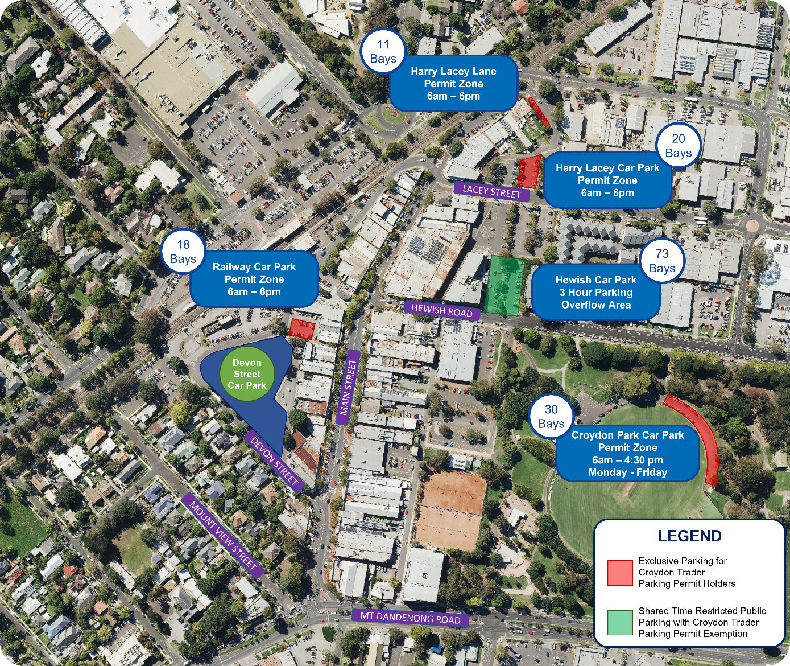

Parking Areas are subject to regular review and may be changed as needed. Permit holders will be notified in writing prior to any changes to parking controls.

