Application for a Tree Removal Planning Permit

01 July 2023 - 30 June 2024

Use this form to apply for a planning permit to Remove, Destroy or Lop Trees or for a permit to remove areas of Native Vegetation.

Need Help?
Please contact Statutory Planning if you need help completing this form or if you are unsure about the information we need to process the application. You can also visit www.maroondah.vic.gov.au or call us on 1300 88 22 33. You can also apply online.

Privacy

Maroondah City Council (Council) is committed to protecting your privacy as prescribed by the Planning and Environment Act 1987 (PE Act) and the Privacy & Data Protection Act 2014 (PDP Act).

Use this application form if you consent to Council publishing all planning application data on its Internet site.

If you cannot agree to this requirement, please contact Statutory Planning Administration for alternate lodgment procedures. You will be required to submit ‘redacted’ copies of all documents in addition to those required to assess the application to satisfy this condition.

The PE Act requires Council to make copies of various documents available for inspection by the public.

Your application and the personal information on this form is collected by Council for the purposes of the application process as set out in the PE Act.

If you do not provide your name and address, Council will not be able to consider your application.

Your application will be published on Council’s Internet site www.maroondah.vic.gov.au and will be available at the Council office for any person to inspect on request in accordance with the public availability requirements in the PE Act.

Copies may also be made available on request to any person for the relevant period set out in the PE Act.

You can request access to your personal information by contacting Council’s Privacy Officer on

1300 88 22 33 or email– privacy@maroondah.vic.gov.au

Copyright

You must not submit any personal information or copyright material of any other individual without their informed consent. By submitting the material, you agree that the use of the material as detailed above does not breach any third party’s right to privacy and copyright

Privacy Declaration * |  |  |  | *Mandatory information
 | I agree to all submitted information being published on Maroondah City Council’s internet site.
Signature |  |  | Date

Affected Property Details – The land on which the tree(s) is growing
Street Address*

Suburb |  | Postcode

Applicant and Owner Details
Contact information
All application correspondence will be sent to the email address below.
Name*
Email* |  |  |  |  |  | Phone*
Applicant* The person who wants the permit.
Title |  | First Name |  |  | Surname
Organisation |  | (if applicable)
Address
Owners details
The person or organisation who owns the land.
Where the owner is different from the applicant, provide the details of that person or organisation.
Title |  | First Name |  |  | Surname
Organisation |  | (if applicable)
Address
Owner’s Signature (optional) |  |  |  |  |  |  | Date

The Proposal
Total number of trees to be removed, lopped or destroyed: _________
The location of each tree must be shown on a plan of the affected property (example provided overleaf). Please identify each tree by a common name or by their genus and species (if known).
Tree Number | Common name or genus and species (if known) |  | Remove |  | Lop
Tree # 1
Tree # 2
Tree # 3
Tree # 4
Tree # 5
Tree # 6
Have there been any permits granted to remove, destroy or lop 1 Tree in the past 12 months for this address? |  |  | Yes |  | No
Are there any applications currently with Council to remove, destroy or lop 1 Tree at this address? |  |  | Yes |  | No
Reasons for the trees to be removed, destroyed or lopped
Proposed replacement canopy tree planting
(Please also show location of replacement plantings on your plan of the site)

If applying within a Vegetation Protection Overlay (VPO), please also specify the patch / area (m²) of native vegetation to be removed. The VPO protects all Victorian native/ indigenous vegetation, including trees, shrubs and ground covers.

Site inspection and access
Council’s Environmental Planners will need to access your property to assess the tree(s).
This allows Council to efficiently assess your application.
Council officers may enter your property at any time once a planning application is made.
Is access restricted? (eg locked side gate) |  | Yes |  | No
Comment
(eg. gates will be left unlocked)
Are there dogs (or other pets) present and how will they be restrained during Council’s inspection? |  | Yes |  | No
Comment
(eg. kept inside)

Title Information
Does the proposal breach, in any way, an encumbrance on title such as a restrictive covenant, section 173 agreement or other obligation such as an easement or building envelope?

Encumbrances on title* |  | Yes (contact Council for advice on how to proceed)
 |  | No
 |  | Not applicable (no such encumbrance applies)
Provide a full, current copy of the title for each individual parcel of land forming the subject site. (The title includes: the covering ‘register search statement’, the title diagram and the associated title documents, known as ‘instruments’ eg restrictive covenants.)

Application Declaration
This form must be signed. Complete either A, B or C.
Remember it is against the law to provide false or misleading information, which could result in a heavy fine and cancellation of the permit.
A | Applicant  I declare that I am the applicant; and that all the information in this application is true and correct and the owner (if not myself) has been notified of the permit application.  You must be the Owner, or have Owner’s consent, to enact any permit which may be issued as a result of this application.
 | Signature |  | Date
B | Owner  I declare that I am the owner of the land and that all the information in this application is true and correct.
 | Signature |  | Date

Site Plan

You must submit information with your application that clearly identifies the tree/s proposed for removal (or lopping)

This can take the form of:
- A drawn site plan (refer to examples A & B below)
- An aerial photo of the site, with the tree/s clearly marked
- Architectural drawings / historic site plans

You can copy an aerial photo from Council’s maps
www.maroondah.vic.gov.au/Explore/About-our-city/Maps-of-Maroondah/Online-mapping
- Open Online Mapping and search for your address
- Select to show Aerial Images
- Zoom in/out as required
- Right mouse click and select “copy image”
- Paste image into an editable document eg. Word and mark the affected trees
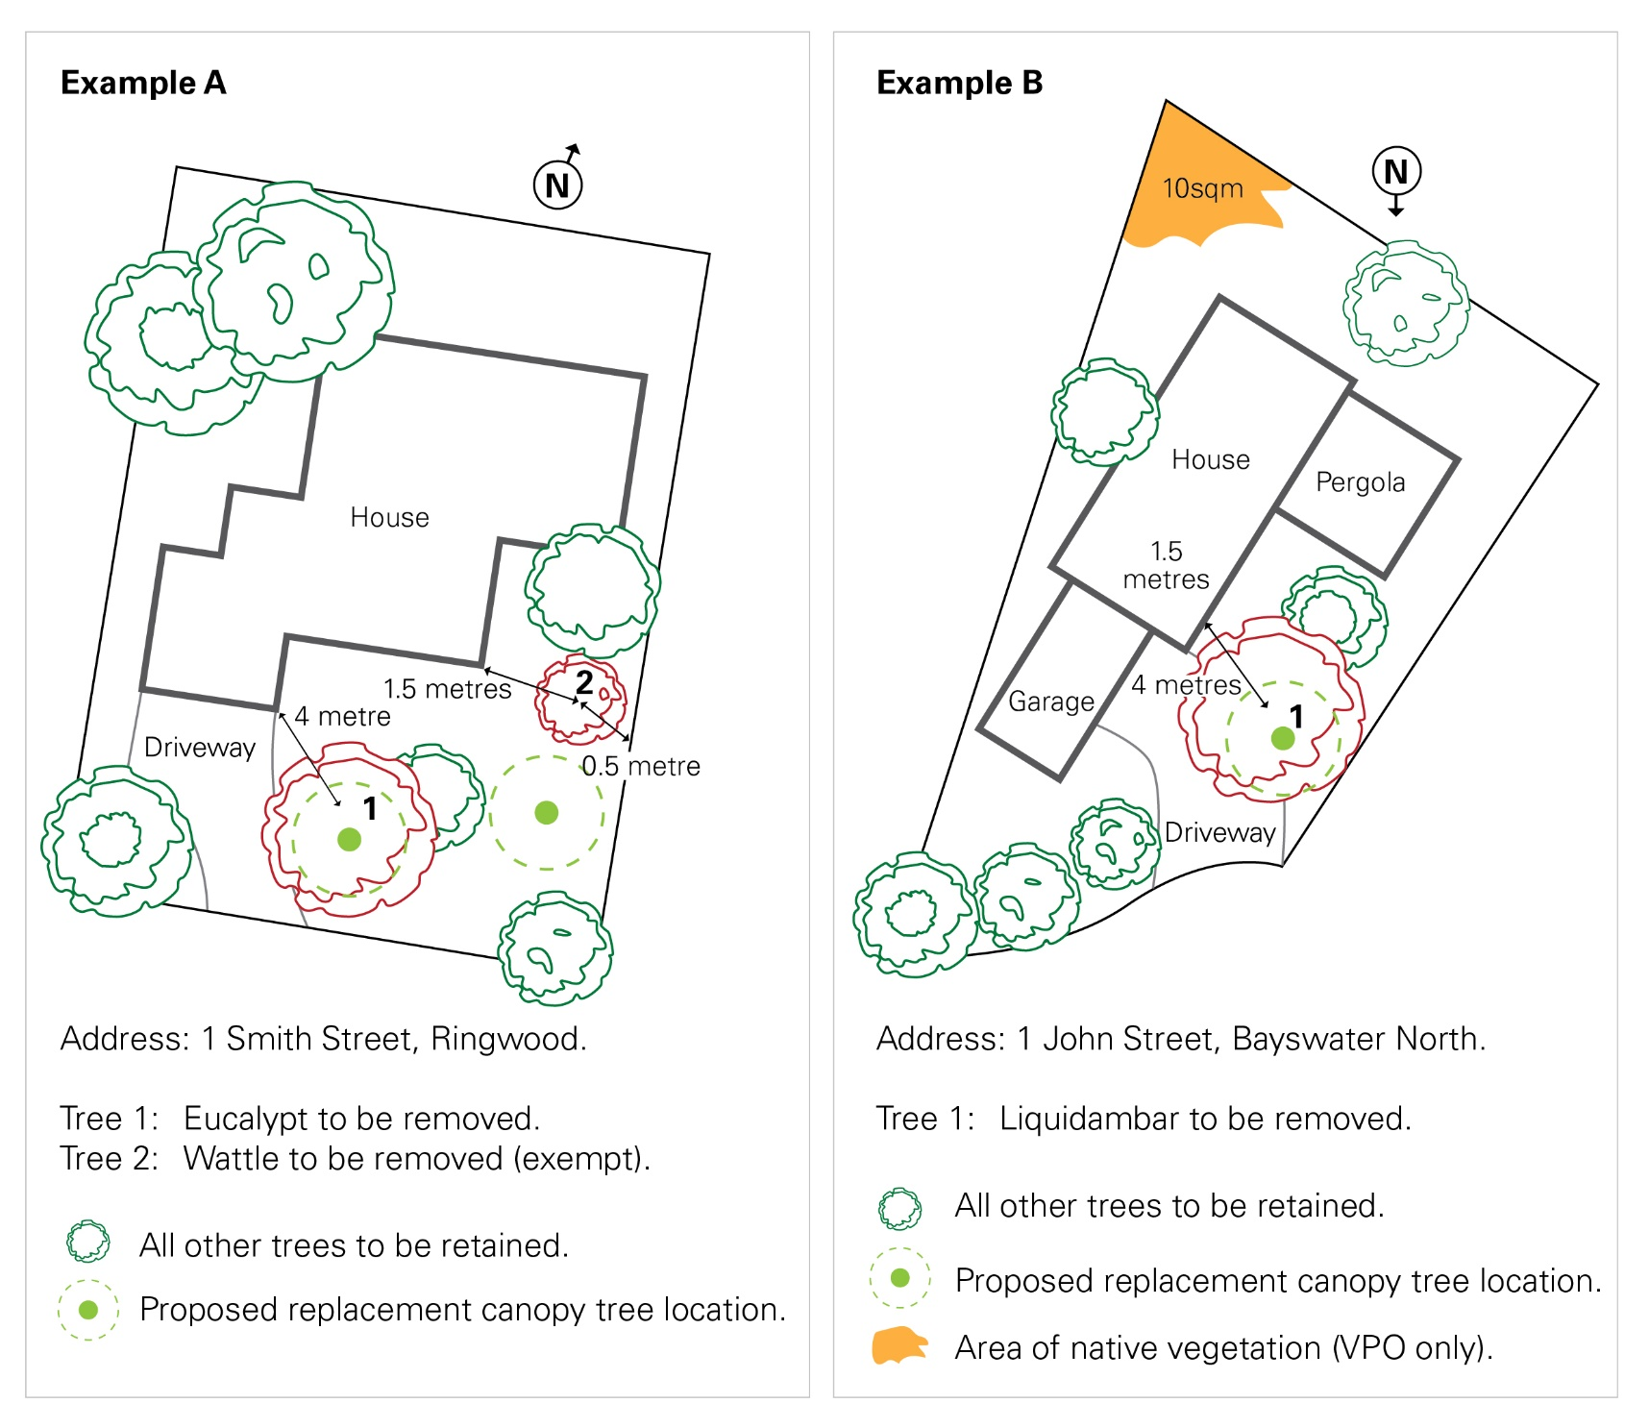

Lodgment and Payment Options
Application with Cheque or Money Order can be posted to PO Box 156 Ringwood 3134.
Applications can be made and paid in person at our Customer Service Centres:

Realm, Ringwood Town Square, 179 Maroondah Highway, Ringwood (Opposite Ringwood Station)
Hours: 9am-8pm Monday - Friday, 10am-5pm Saturday, Sunday and public holidays

Croydon Library, Civic Square, Croydon
Hours: 8.30am-5pm Monday - Friday

Fees

Application fees vary depending upon the overlay that applies to the land. All fees include GST.

You can check your planning overlays by searching for your address on VicPlan - the Victorian State government planning mapping website: mapshare.vic.gov.au/vicplan/

In the Significant Landscape Overlay (SLO), Heritage Overlay (HO) or Neighborhood Character Overlay (NCO) fees apply per tree up to 6 or more trees.

For applications in within a Vegetation Protection Overlay (VPO) or pursuant to Clause 52.17 Native Vegetation (Cl 52.17) a flat fee of $293.00 applies.

 | SLO, HO, NCO | VPO, Cl 52.17
Removal of 1 tree | $141 | $293
Removal of 2 trees | $171 | $293
Removal of 3 trees | $202 | $293
Removal of 4 trees | $232 | $293
Removal of 5 trees | $263 | $293
Removal of 6 or more trees | $293 | $293

